
JC2 PRELIMINARY EXAMINATION
TAMPINES MERIDIAN JUNIOR COLLEGE

CANDIDATE
NAME
CIVICS GROUP
_________________________________________________________________________________
H2 GEOGRAPHY 9173/01
Paper 1 12 September 2024 3 Hours
Additional Materials: 12 Page Answer Booklet
1 Insert ____________________________________________________________________________

READ THESE INSTRUCTIONS FIRST

Write your answers in the answer booklet provided. You should follow the instructions on the front cover of the answer booklet. If you need additional answer paper, ask the invigilator for a continuation booklet.

Answer all questions.

The Insert contains all the Resources referred to in the questions.
You should make a reference to appropriate examples studied in the field or the classroom, even where the examples are not specifically requested by the question.
Diagrams and sketch maps should be drawn wherever they serve to illustrate an answer.
You are reminded of the need for good English and clear presentation in your answers.

The number of marks is given in the brackets [ ] at the end of each question or part question.

______________________________________________________________________
This document consists of 4 printed pages
Section A

Answer both questions

Cluster 1: Development, Economy and Environment

1 |  | Resource 1 shows the types of energy resources used for electricity generation in selected countries, 2017.  Resource 2 shows the global distribution of solar power energy plants.  Resource 3 shows the distribution of employment by sector for LICs and HICs, 1991 and 2018.
 | (a) | Describe the variations in the types of energy resources used for energy generation for the countries shown in Resource 1. | [5]
Award 1m for description and allow the development of one point for a second mark.

- Fossil fuels are the most common fuel (1m) 58% or more in 13/15 countries/ Brazil and Canada are anomalies with much lower fossil fuels (less than 30%) (1m).
- HEP is the largest alternatives to fossil fuels (1m) but not found everywhere (with Saudi the exception).
- Wind and solar are the smallest contributors but are contributors everywhere(1m)
- Amount of renewable energy is inversely proportional to the amount of fossil fuels (1m)
Other valid points

 | (b) | Using Resource 1 and your own knowledge, explain the limitations of hydroelectric power (HEP) as an alternative to fossil fuel. | [4]
- Geographical limitations: not everywhere will have fast flowing rivers and have access to hydropower (1m) e.g. Saudi Arabia (1m)
- Inadequate power supply (1m) still need to rely on fossil fuel (1m)
- May not be most stable (1m) prone to suffer from droughts and other climatic conditions (1m).
- Use of HEP may lead to political conflict with downstream states (1m) such as in the Nile River between Egypt and Ethiopia (1m)
 | (c) | Using Resource 2, describe the distribution of solar power plants globally. | [3]
- More in Northern Hemisphere than Southern Hemisphere
- Mostly concentrated at lower latitudes
- Mostly in DCs: USA, Most of Europe
- Highest concentration in Europe, lower concentration in continents of S.America and Africa

 | (d) | Account for the pattern of distribution as seen in Resource 2 | [4]
- Lower latitude areas receive more insolation all year round, so it is more viable to build solar power plants as there is more insolation compared to higher latitude areas, where less insolation in the winter months
- More in DCs than LDCs as solar energy requires higher infrastructural costs and technical expertise to construct
 | (e) | Compare the changes in employment for LICs and HICs shown in Resource 3 | [4]
Compare the changes in employment for LICs and HICs shown in Fig. 10.1. Comparisons include:
• Both have falls in agriculture, LICs by 8%, HICs by 3%, but more decline in LICs, (in HICs from 6% to 3%, whereas in LICs 70% to 62%),
• Both have increases in services LICs +5%, HICs +11%, but more so in HICs (64%–75%), whereas 21–26% in LICs,
• Manufacturing sector remains at 6% in LICs, but falls in HICs (20% to 12%)
• Both are still dominated by one sector (LICs agriculture, HICs services), but the dominance of services in HICs has increased, whilst in LICs agriculture has fallen
• In both groups, construction shows little change but has grown in LICs (2% to 4%), whilst it stays the same in HICs (8%)
• Mining rises from 1 to 2% in LICs and remains the same (2%) in HICs but is the smallest in both
• Other comparisons may be valid 1 mark for each valid comparison.

Allow development of one change for a second mark such as the comments following ‘but’ above in each bullet point. Max. 1 for two separate descriptions of changes in LICs and HICs. Max. 2 for no data. Allow ±1% tolerance for data reading.

 | (f) | Using Resource 3, explain the distribution of employment by sector for LICs and HICs in 2018. | [4]
- Labor characteristics and skills – HIC have higher skilled labor that are more well educated and equipped to work in service sector compared to LICs which have less skilled workers but lower cost of labor so they work in these sectors.
- Infrastructure of countries / govt policy
 | (g) | Explain how multilateral institutions can affect economic activities for countries at lower levels of development. | [6]
- Multilateral Institutions like World Trade Organisation (WTO) regulates global trade and operates through encouraging multilateral trade. For example, WTO limits the amount of tariffs a country can impose to ensure trade between countries can flow freely. Also, WTO has regulated global commerce by encouraging countries to open its market. Since China joining the WTO in 2001, its exports and imports grew by 8 times between 2001 and 2014, growing from the 6th largest to the 2nd largest economy in the world today and develop socially and economically through growth in exports and commerce.
- Multilateral Institution like ASEAN (elaborate what it is) Between 1993 to 2016, ASEAN’s total trade increased from USD$430 billion to USD$2.2 trillion. The share of intra-ASEAN exports and imports have also increased. On a country’s level, Vietnam’s trade with other ASEAN countries increased almost 10 times from US$5.9 billion in 1996 to $56.3 billion in 2018. This shows that AFTA has been successful in promoting trade between countries, and helping member countries like Vietnam to develop economically
- The World Bank promotes long-term economic development and poverty reduction by providing technical and financial support to help countries implement reforms or projects, such as building schools, providing water and electricity, fighting disease, and protecting the environment.
- Many LDC countries rely on support on WB to help them improve infrastructure and human resources so that they can better participate in the global economy and increase economic activities such as employment and trade between their countries and the developed countries. For instance, the WB help funded over 200km of roads in Mozambique that help connected poor farmers in rural areas to be able to sell and export their agricultural products increasing their income, with this project benefitting over 200,000 people and allow Mozambique to better develop in the global economy with the infrastructure to aid in increasing its exports.

Cluster 2: Tropical Environments

2 | Resource 4 shows climographs of two different tropical climates in Southeast Asia.  Resource 5 shows a picture of the High Country Rivers in New Zealand.  Resource 6 shows the landslide potential map of mainland USA.
 | (a) | Compare the two climographs shown in Resource 4 | [4]
- Both have distinct wet and dry season + cite data
- Their wet season occur at different times of the year, Quy Nhon is later
- Quy Nhon have higher total annual precipitation, 666mm more than Luang Prabang

- Both have high Mean Annual Temperature/Average Annual Temperature of above 23.9 deg C
- Quy Nhon is hotter/warmer than Luang Prabang with 2deg C more in AAT/MAT
- Both have similar ATR of 7deg C

 | (b) | Using Resource 4, account for the difference in rainfall and temperature of Luang Prabang and Quy Khon | [6]
- Difference in rainfall amount and timing: Continentality as Luang Prabang is more inland and affected by SW Summer monsoon in the middle of the year. In contrast, Quy Nhon gets more rainfall being coastal and the monsoon occurs later because it is the NE Winter Monsoon.
- Differences in A.A.T: Quy Nhon warmer in total as lower latitude, higher angle of incidence, less beam spreading.
No marks for ATR as their ATR is similar

 | (c) | Draw a cross-section sketch of X to Y, label the main features | [3]
 |  | Title, Mid Channel bar with sparse vegetation, braided streams
 | (d) | Explain how the formation of the river channel shown in Resource 5 is formed | [4]
 |  | - Explain how erosion, transport and deposition changes across wet and dry seasons causing channel to widen and mid channel bars to accumulate and form.
 | (e) | Describe the distribution of landslides as shown in Resource 6 | [4]
 |  | 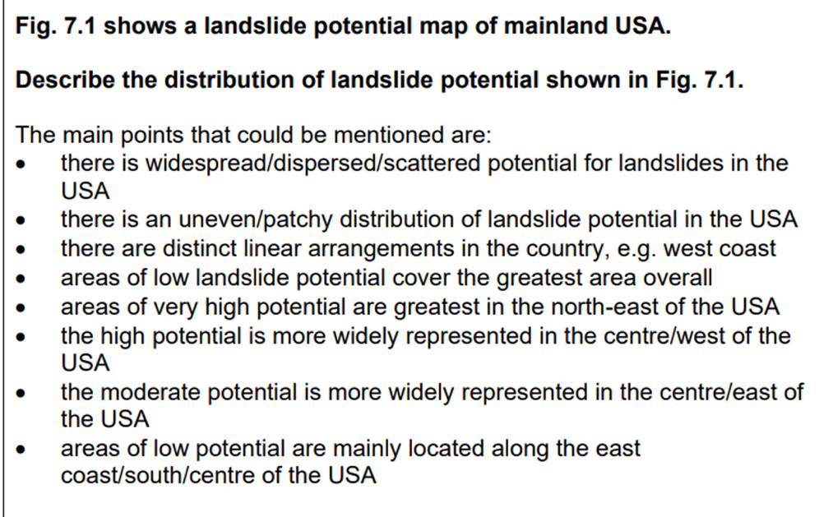
 | (f) | Explain why some areas are more prone to landslides than others | [4]
Most importantly, answer must have mention of shear strength and shear stress

- Areas with more human activities such as urbanization and construction on slopes increase shear stress
- Areas with more deforestation reduce shear strength
- Areas prone to natural hazards like earthquakes –> reduce shear strength
Accept any other possible answers but it must relate to landslides and not mudflows or creep.

 | (g) | Explain how water erosion can influence movements of materials on slopes. | [5]
- On barren slopes or slopes with sparse vegetation
- Rainsplash erosion
- Rainwash
- Rills and gullies
Explain how materials move downslope via these syllabus points

3 | ‘Trade-offs are necessary to achieve Sustainable Development’.  Evaluate this statement. | [20]
 | Students can discuss if economic, social and environmental goals of sustainable development requires trade-offs. And how does it vary from DCs to LDCs. A good quality answer will discuss how it varies across space and if trade-offs can be avoided while countries pursue all other goals at the same time.
4 | Evaluate the causes of transboundary water conflict. | [20]
 | Students can discuss the causes of transboundary water conflict, social, economic, environmental and political causes of water conflict and discuss if any of the above factor is a main reason for conflict or if there is a deeper underlying factor that tends to affect other factors. Students can also assess if it varies from place to place. Showing an understanding of how geography matters.

Cluster 2: Tropical Environments

5 | ‘Tropical cyclones are the main cause of fluvial flooding in the tropics.’  Evaluate this statement.  Student can support with examples how tropical cyclones are the main cause of fluvial flooding in the tropics. They can then contrast it with other factors such as climate e.g. Monsoon climates ; or human factors such as dam failures, levee breach. Higher level response would highlight how natural factors are more primary and causing floods while human factors are more secondary. | [20]
6 | Evaluate the factors affecting the storages and pathways in drainage basin systems in the tropics. | [20]
 | Students can discuss how different factors such as climate, geology, vegetation affects the drainage basin in the tropics. Evaluating how climate could affect input and the different rainfall amount, discussion of different types of pathways and storages. Student can then come to a conclusion on which is a more important factor.

